CREATE TABLE student(

Register_no NUMBER(20),Name VARCHAR(38),Date_of_Birth DATE

);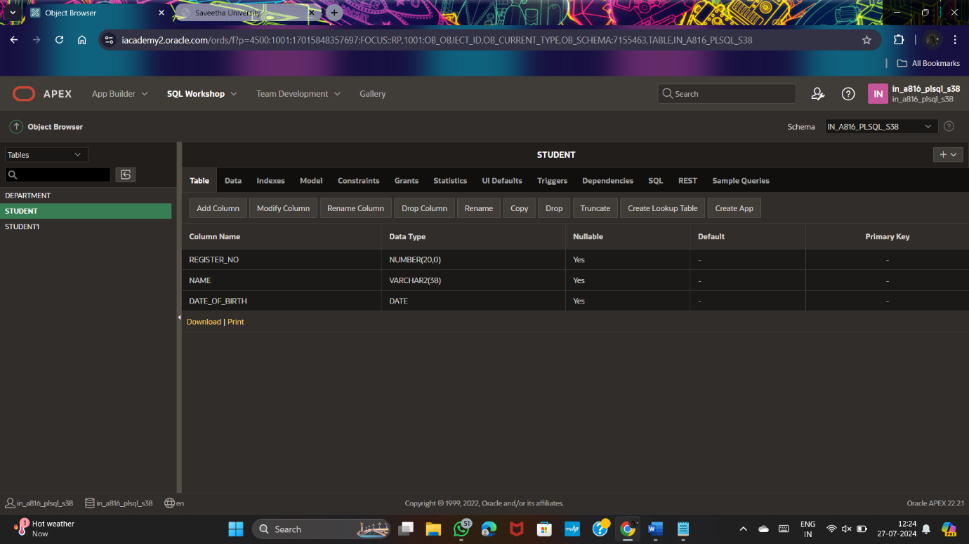

ALTER TABLE student

ADD bloodgrp VARCHAR(20);

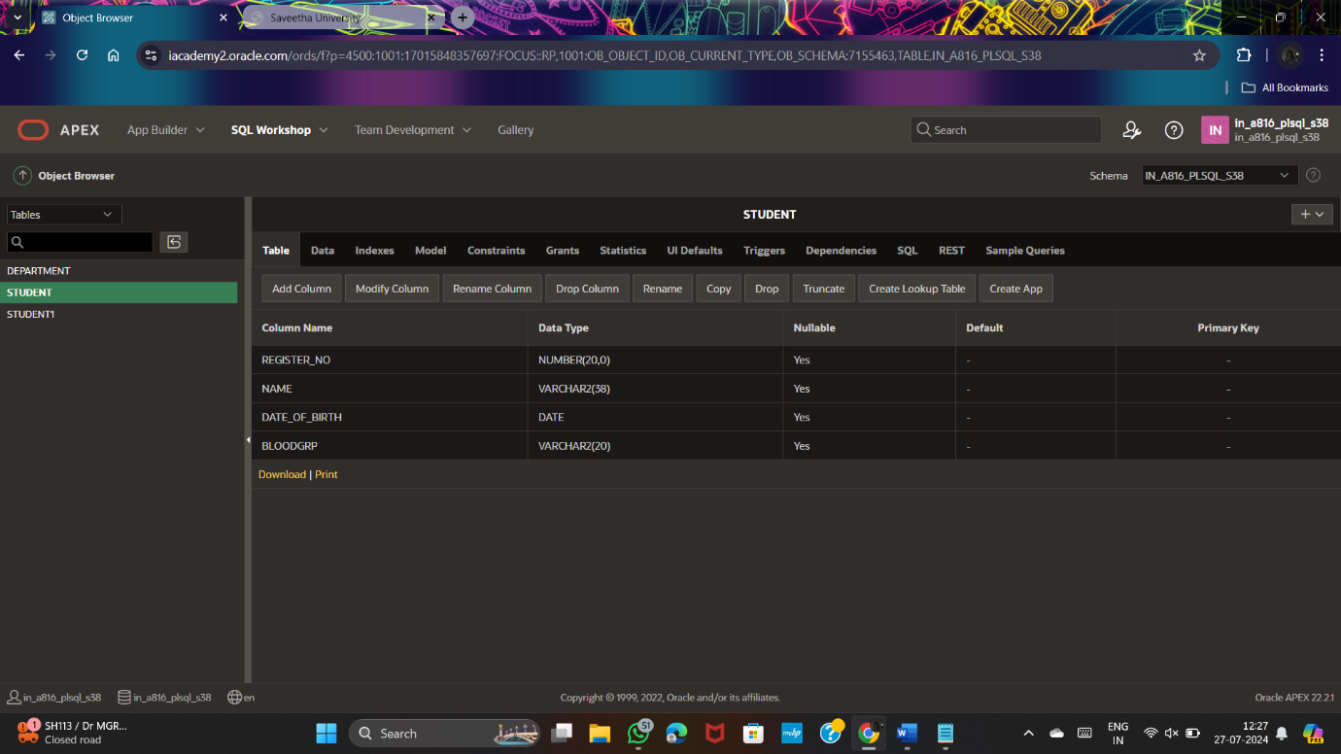

ALTER TABLE student ADD PRIMARY KEY (register_no);

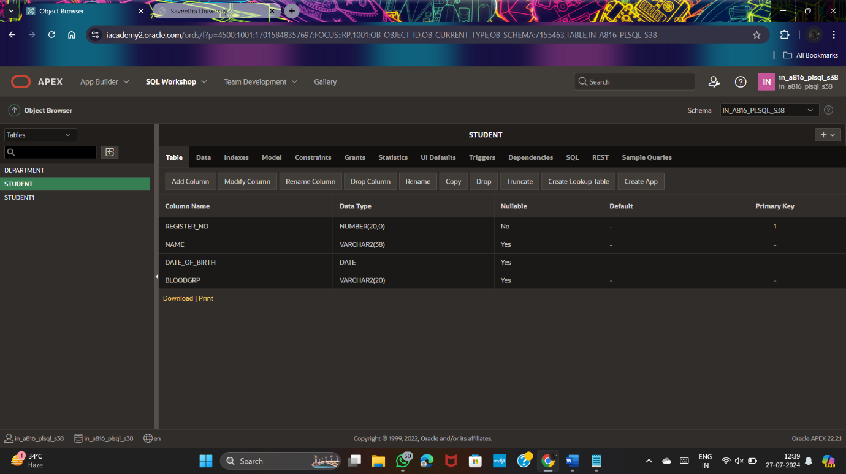

ALTER TABLE student

ADD use_less VARCHAR(20);

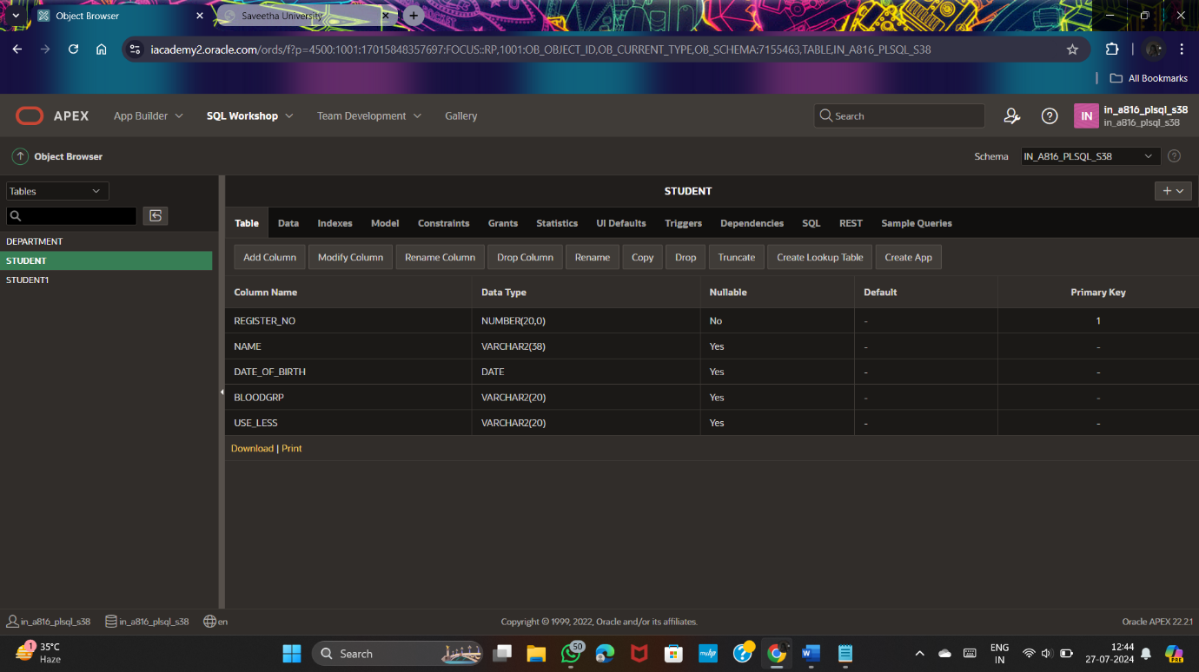

ALTER TABLE student

DROP (use_less);

ALTER TABLE student

RENAME COLUMN register_no TO Regno;

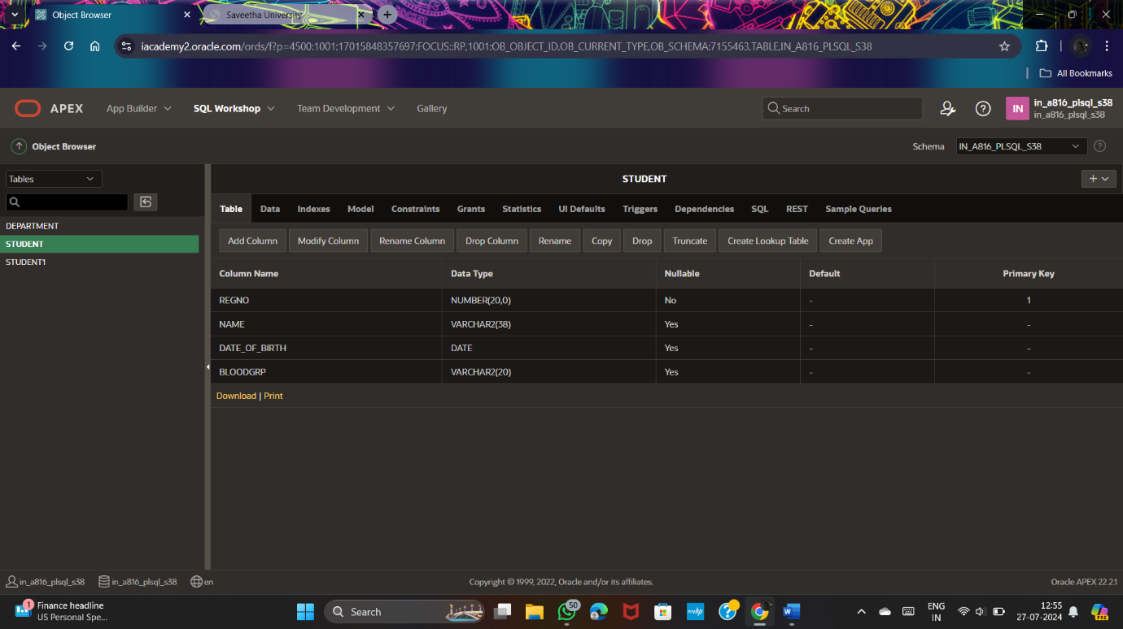

ALTER TABLE student

MODIFY std_name VARCHAR(38) NOT NULL;

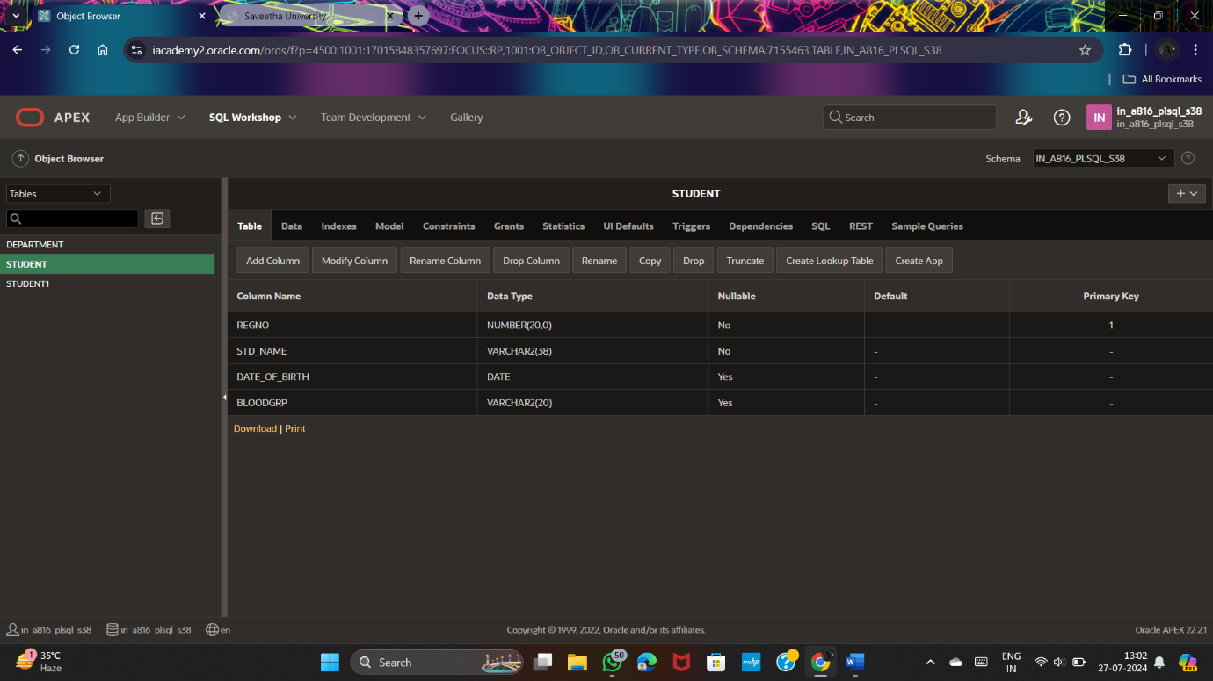

ALTER TABLE student

MODIFY Date_of_Birth NUMERIC NOT NULL;



INSERT INTO student VALUES(059,'shini',2000,'A');

INSERT INTO student VALUES(057,'bob',2000,'B');

INSERT into student VALUES(056,'ken',2001,'O');

INSERT INTO student VALUES(055,'jen',2003,'AB');

INSERT INTO student VALUES(052,'kate',2005,'B');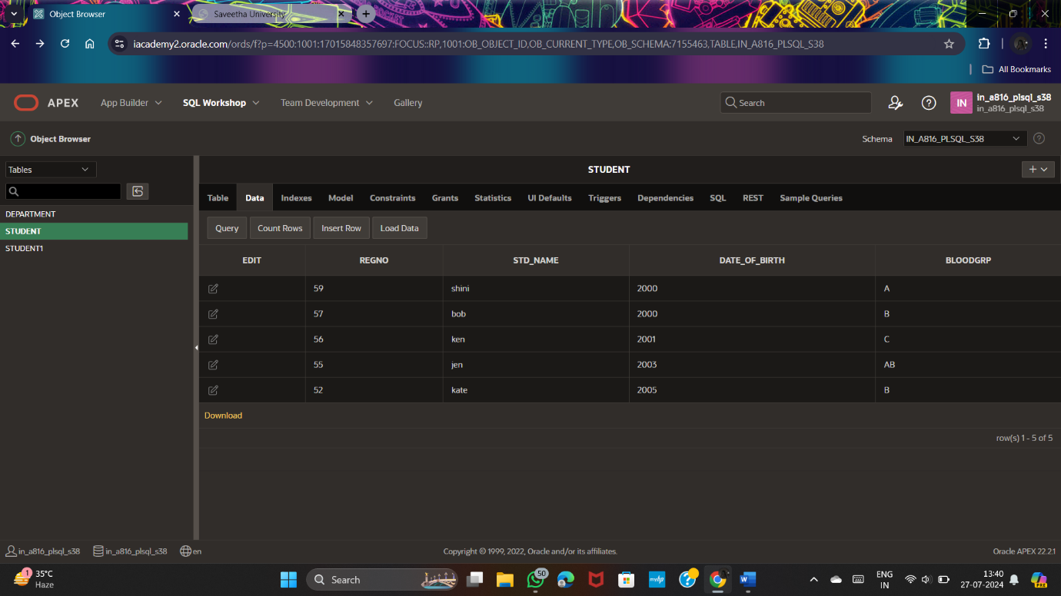

SELECT * FROM student

ORDER BY Regno;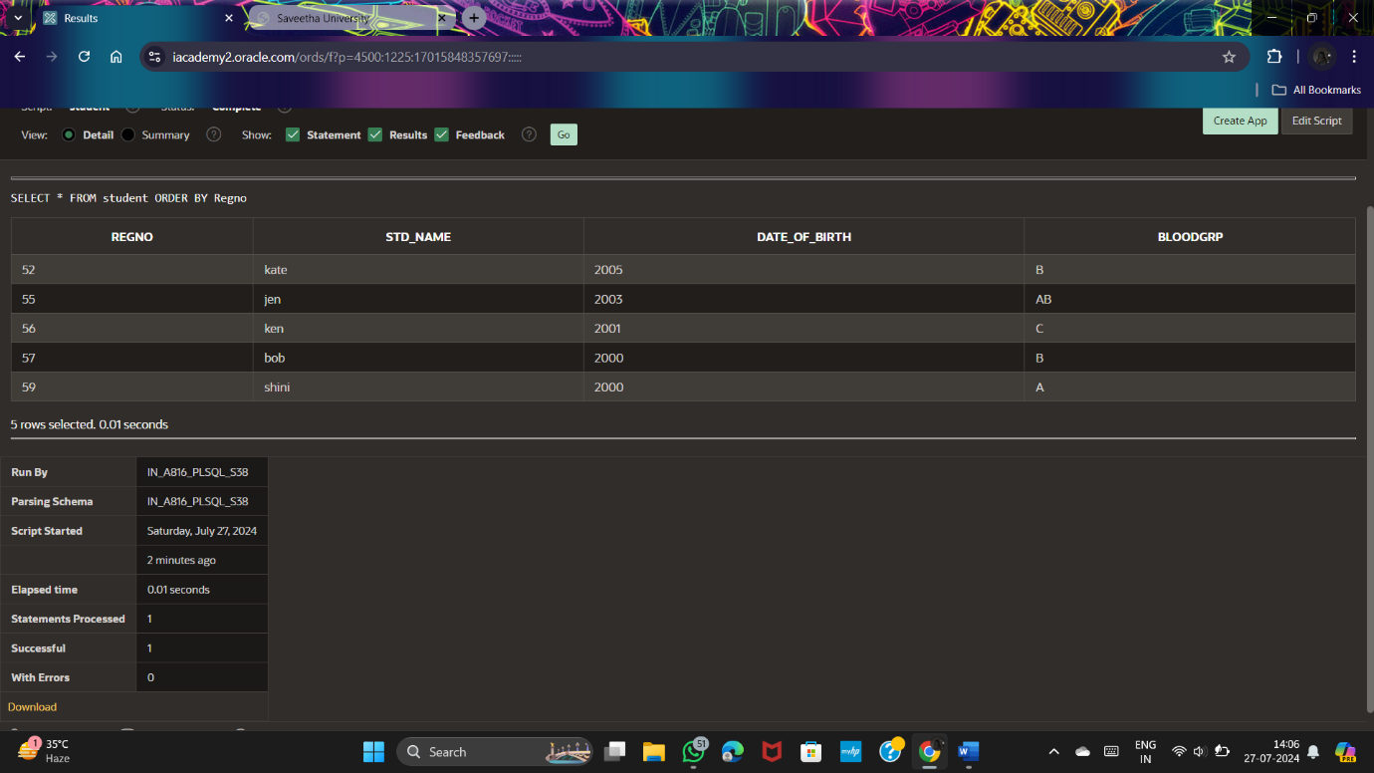

SELECT * FROM student

WHERE Regno BETWEEN 52 AND 59;

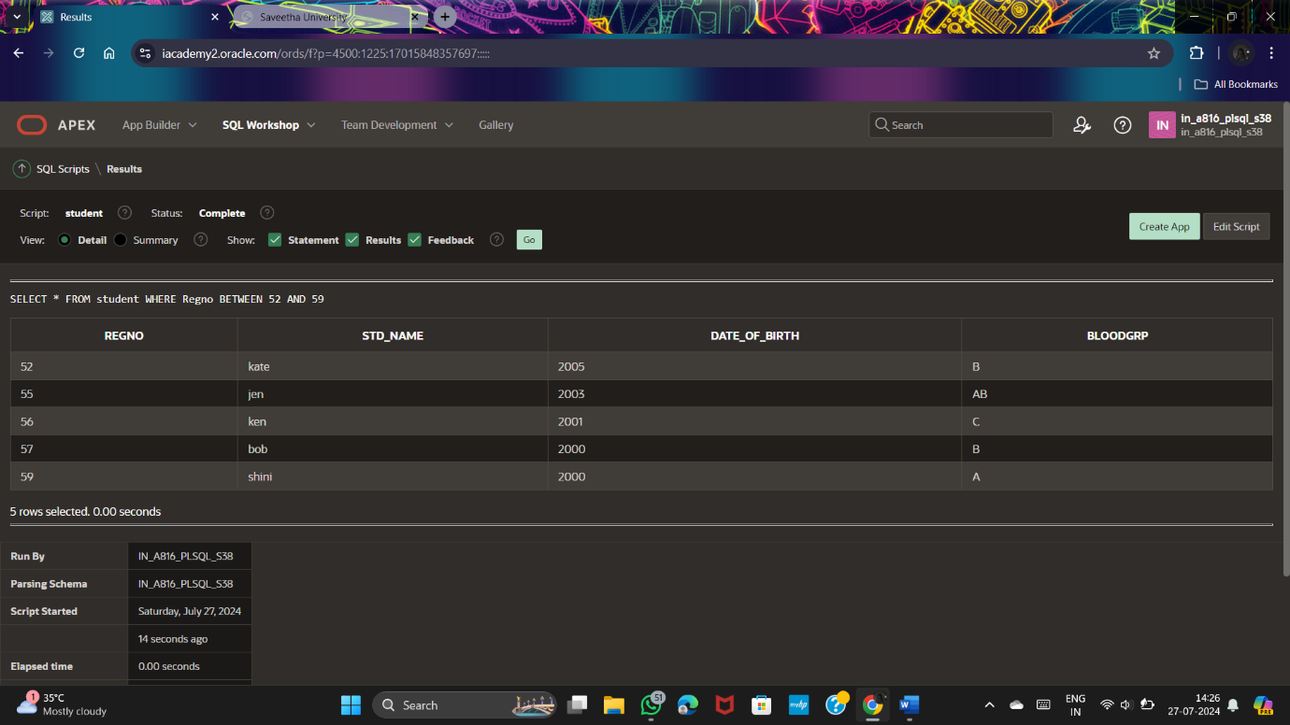

DELETE FROM student

WHERE bloodgrp = 'o';

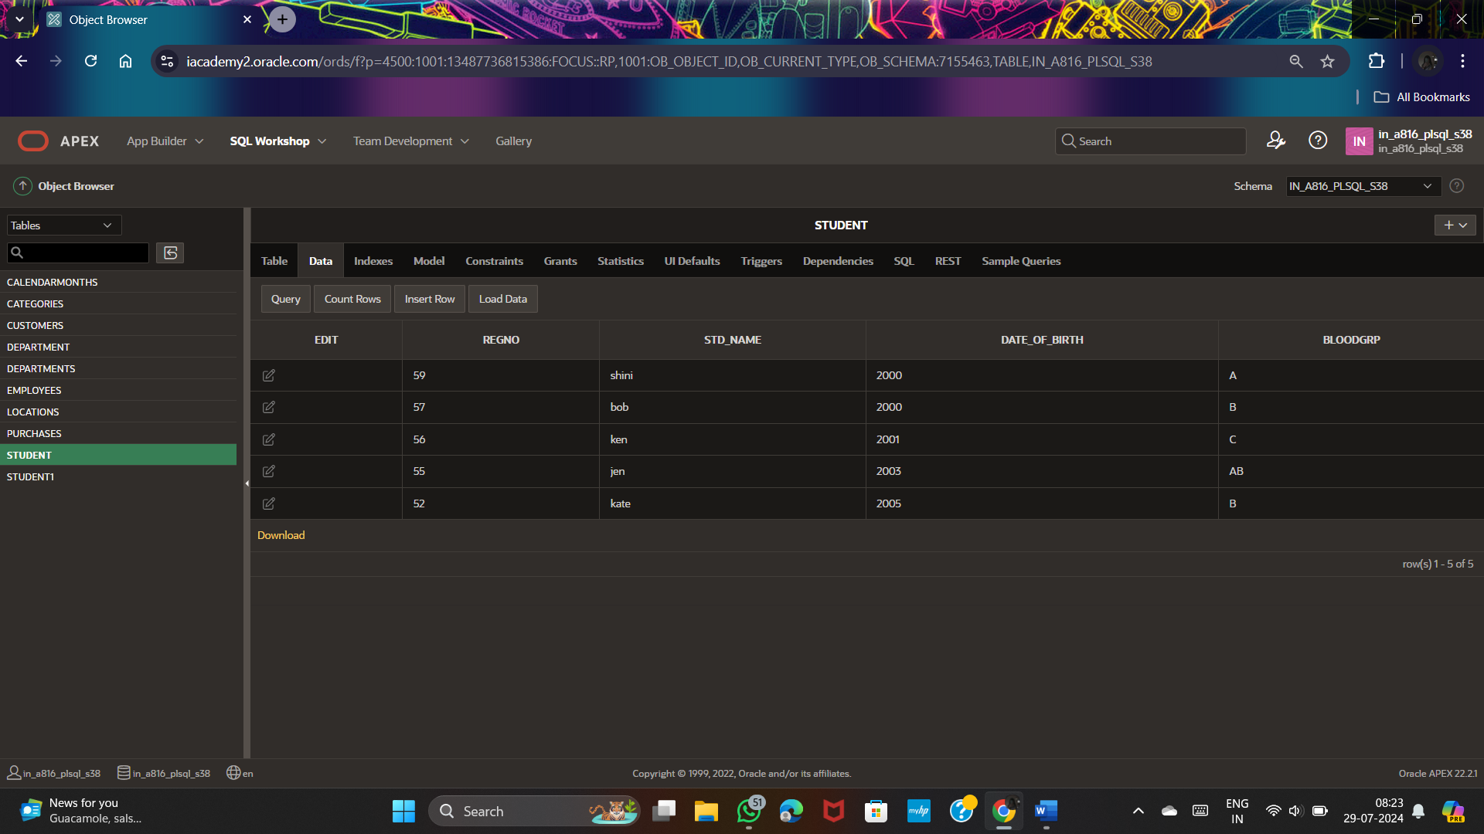

DELETE FROM student;

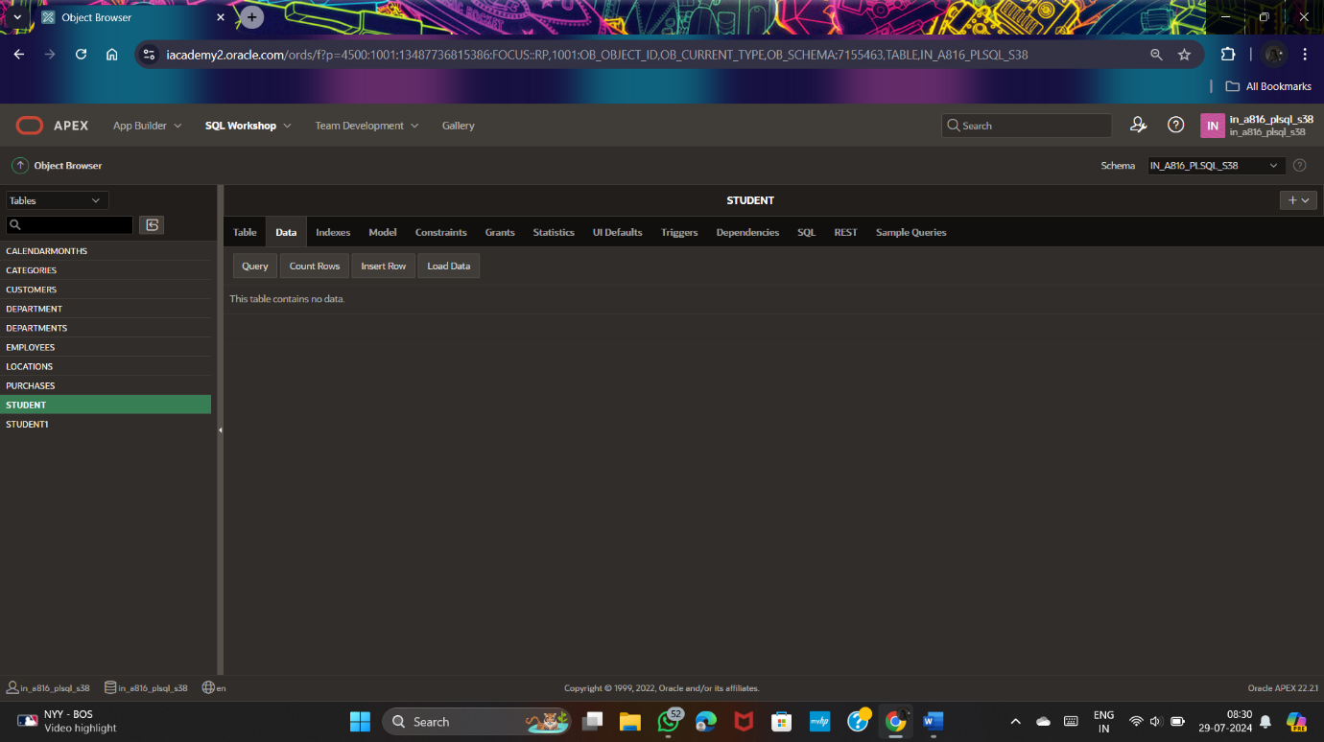

DROP TABLE student;

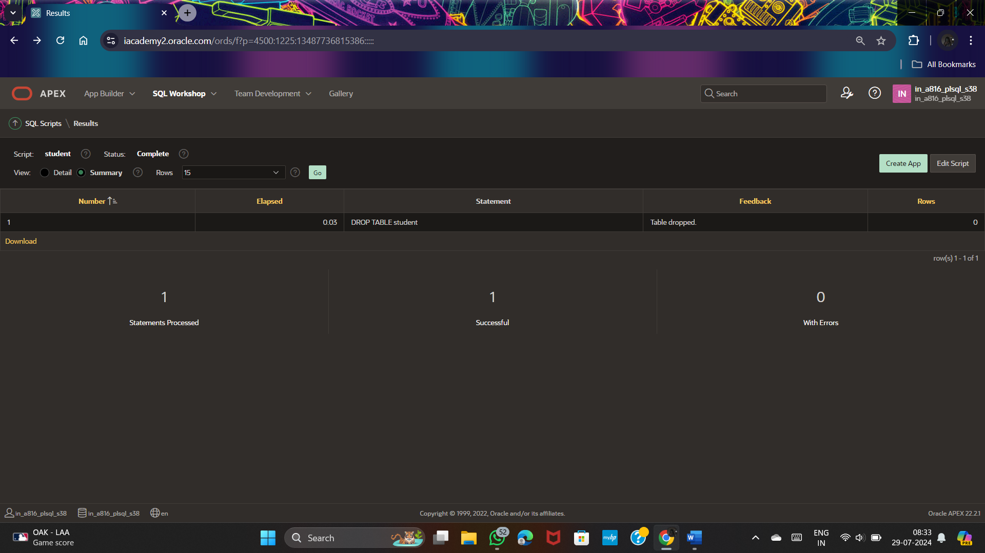

SELECT drname||last_name

AS hos_name FROM hospital;

